# SRS for Food Delivery Website and Application

**By**

**T.Abinaya**

**S.Kaneshiya**

**M.Oviya**

**R.Preethi**

**Table of Contents**

**1. INTRODUCTION**

**1.1. Objective**

**1.2. Scope**

**1.3. Glossary**

**2. OVERALL DESCRIPTION**

**2.1. Product Perspective**

**2.2. Hardware Requirements**

**2.3. Software Requirements**

**2.4. Functinal Requirement**

**2.5. Non-Function Requirement**

**1.Portability**

**2.Reliability**

**3.Avilability**

**4.Maintainability**

**5.Security**

**6.User Friendly**

**7.Performance**

**8.Efficiency**

**9.Safety**

**10.Privacy**

**3. USER CHARACTERSTICS**

**4. DIAGRAM**

**4.1. User Case Diagram**

**4.2. Class Diagram**

**4.3. Sequence Diagram**

**4.4. Activity Diagram**

**4.5. System Diagram**

**5. REFERENCES**

**1. INTRODUCTION**

Food ordering system these days has one of the fastest growing markets. In this project, we have developed something like the same to learn from and serve the nation in a much better way possible. Nowadays, people are more regular to dine-in at the restaurant for their meals. The online food ordering system provides convenience for the customers that are nothing special but the general busy people of the society. It overcomes the demerits of the manual hotel or mess system and the old-fashioned queuing system. This system enhances the readymade of foods than people. Therefore this system enhances the speed of getting food in person's plate and quality and manner of taking the order from the customer. It provides a better communication platform. The user's details are stored using the electronic media. The online food ordering system provides the menu online and the customers can easily place the order by just clicking the mouse or by touching a button on their smart phones. Also, with thefood ordering system online, people can easily track their orders, and admin can maintain customer's database and advance the food delivery system. This food ordering system allows the user to select the desired food items from a list of available menu items provided by the local hotel or restaurant. The user can place orders for the food items of their like from the list. The payment can be made online or pay-on-delivery system. The user's details are maintained confidentially because it maintains a separate account for each user. An id and password are provided for each user. And several encryption techniques have also been used on the server side to protect the card details. Therefore it provides a more secure and safe.

**1.1 Objective**

➤ The study is to develop a reliable, convenient and accurate ordering system.

➤ Provide timely access to request material.

➤ To develop a system that will surely satisfied the customer services.

➤ To design a system able to accommodate huge amount of orders at a time.

➤ To improve the communication between the client and server.

➤ Provide information about the items in categories.

**1.2 SCOPE**

Online Food Delivery System (FOS) is a web application that will allow its users to register and then select the food items of their choice from the menu list and order food online.This application is allowed to user to give feedbackand pay payments of order after there statsification.We will use PHP programming language and MySQL database to develop this application. There will two types of users (Admin and Customer) in this application. Admin have access to monitor everything on the online food ordering system also allow to add ,update and delete the restaurants after sign in.Admin can also verify the order.Customer can view the menu of different restaurants and then select food item of his/her choice to the shopping cart after login.Customer must fill a form providing his/her name, number, address, city, delivery time slot and payment method (cash on delivery) after he/she checkout from the shopping cart.Food will be delivered to the customer at home with respect to the selected time slot.

**1.3 GLOSSARY**

Here there are some clarifications of the terms uses in this document and also some explanation related to the Online Food Ordering and Delivery System.

**2. OVERALL DESCRIPTION**

**2.1 PRODUCT PRESPECTIVE**

This project is about online food ordering and selling website which supports a number of

functions for both the customer and admin. The website must be available to anyone

using a computer or a smart with internet connection.

**2.2 SOFTWARE REQUIREMENT**

➤ Mysql

➤ SQLite.

➤ XAMPP Server

➤ JAVA

➤ XML

➤ PHP

**2.3 HARDWARE REQUIREMENT**

➤ PROCESSOR: Intel(R) Core(TM) i7-7500U CPU @ 2.70GHz 2.90GHz

➤ PROCESSOR SPEED: 250MHz to 833MHz

➤ RAM: 128MB

➤ RAM HARD DISK: 60GB

**2.4. FUNCTIONAL REQUIREMENT**

**⚫ Order Management**

➤ The system shall let the user to place an order for their

consumers.

➤ The system shall prompt and ask user to verify the order that have

been placed.

➤ The system shall allow user to add in extra remark regarding the

order.

➤ The system shall allow user to void the order that mistakenly placed

or exceptional case occur.

**⚫ Reporting Management**

➤ The system shall generate a report that based on the time period

that customize by user.

➤ The system shall retrieve related information from the databaseand

generate the report to user.

**⚫ Menu Management**

➤ The system shall only allow management level user to edit the menu

card information by having an authorization login checking.

➤ The system shall allow user to update their restaurant menu card

information.

**2.5. NON FUNCTIONAL REQUIREMENTS**

**1. Portability:**System running on one platform can easily be converted to run on another platform.

**2. Reliability:**The ability of the system to behave consistently in a user-acceptable manner when operating within the environment for which the system was intended.

**3. Availability:**The system should be available at all times, meaning the user can access it using a web browser, only restricted by the down time of the server on which the system runs.

**4. Maintainability:**A commercial database is used for maintaining the database and the application server takes care of the site.

**5. Security:**Secure access of confidential data (customer information).

**6. User friendly:**System should be easily used by the customer.

**7. Performance:**Performance should be fast.

**8. Efficient:**System should be efficient that it won't get hang if heavy traffic of order is placed.

**9. Safety:**Data in the database of system should not loss or damage.

**10. Privacy:**Personal data of the system should not disclose to anyone.

**3.USER CHARACTERISTICS**

**1.Administrator:**In the OFO the major and sensitive role is played by the admin, to illustrate, he will define the food items, whit quantity, price, data entry of the food item and control the users and customers. Again, how the customer will order to get the items 7 attached to admin panel that should be defined by the admin. In the other hand, all types of approval by the admin authority will be done by the system via admin.

**2.Customer:** Customer are the only users who have chance to add food items in to the cart as an input on OFO system. Customer can only see his/her massages and order details on his/her dashboard Here, s/he will have the option of seeing full Order or cart information sheet.

**3.User:**In the OFO the users only use the system and can browse all the items but cannot make order or add to cart without login. They will give their basic information until the system is approved the correctness of their information and freeze it. The OFO user is simply anyone who has access to the Internet and a web browser or with a smart phone. It is assumed that the user is familiar enough with a smart phone or a computer to operate the browser, keyboard and mouse and is capable of browsing from and within simple websites.

**4.DIAGRAM**

**4.****1USER CASE DIAGRAM**

**4.2.CLASS DIAGRAM**

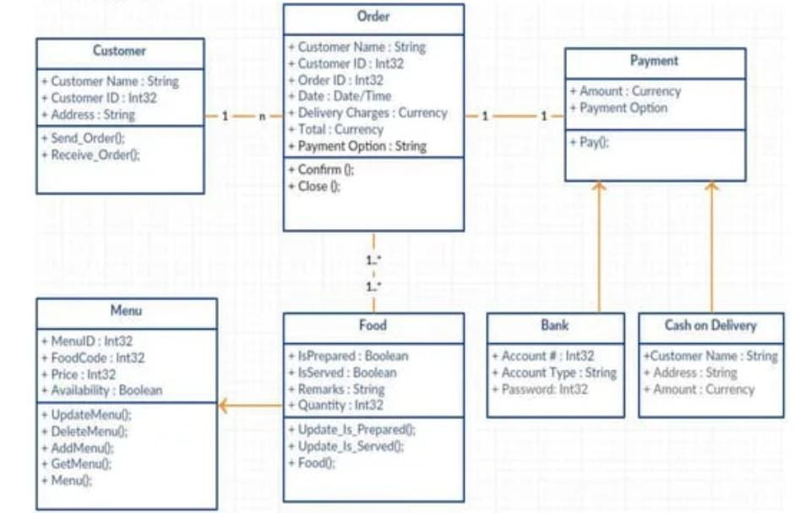

**4.3.SEQUENCE DIAGRAM**



**4.4. ACTIVTY DIAGRAM**



**4.5.SYSTEM MODEL**

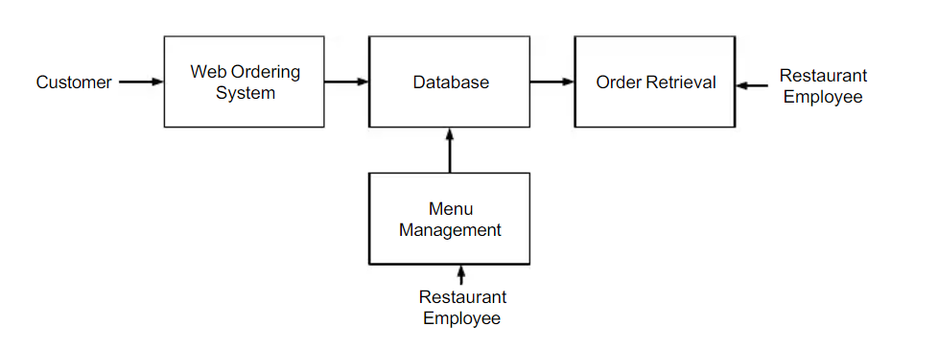

**5.REFERENCE**

App development books

Head first android development-dawn Griffiths

Android programming for beginners-John Horton

Android app development fd -michaep hurton